1. **How many constructors can one class have?**

A class can have one default constructor and as many overloaded constructors as is needed.

1. **Why is the Main method specified with the static keyword?**

The static keyword allows Main to be called without creating an object of the class in which the main method is defined.

1. **Which of the simple data types are reference types?**

The string and object types are reference types

1. **What is the difference between out and ref?**

If you prefix a parameter with the ref keyword, the C# compiler generates code that passes a reference to the actual argument rather than a copy of the argument. Additionally, C# enforces the rule that you must assign a value to a variable before you can read it, and the compiler checks whether a ref parameter has been assigned a value before calling the method. However, if you want the method itself to initialize the parameter, you prefix the parameter with the out keyword so that the method must assign a value to the parameter before it finishes or returns.

1. **Write a for loop that prints out the odd numbers from 1 to 11. Use the compound assignment operator += to increment your counter variable.**

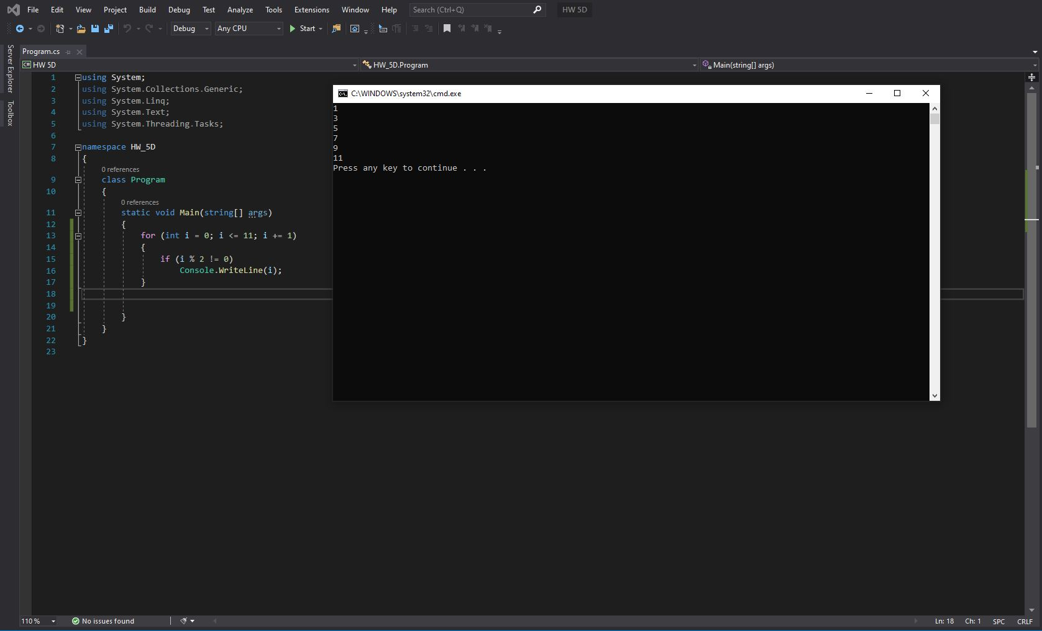

1. **Write a while loop that prints out the odd numbers from 1 to 11. Use the compound assignment operator += to increment your counter variable.**

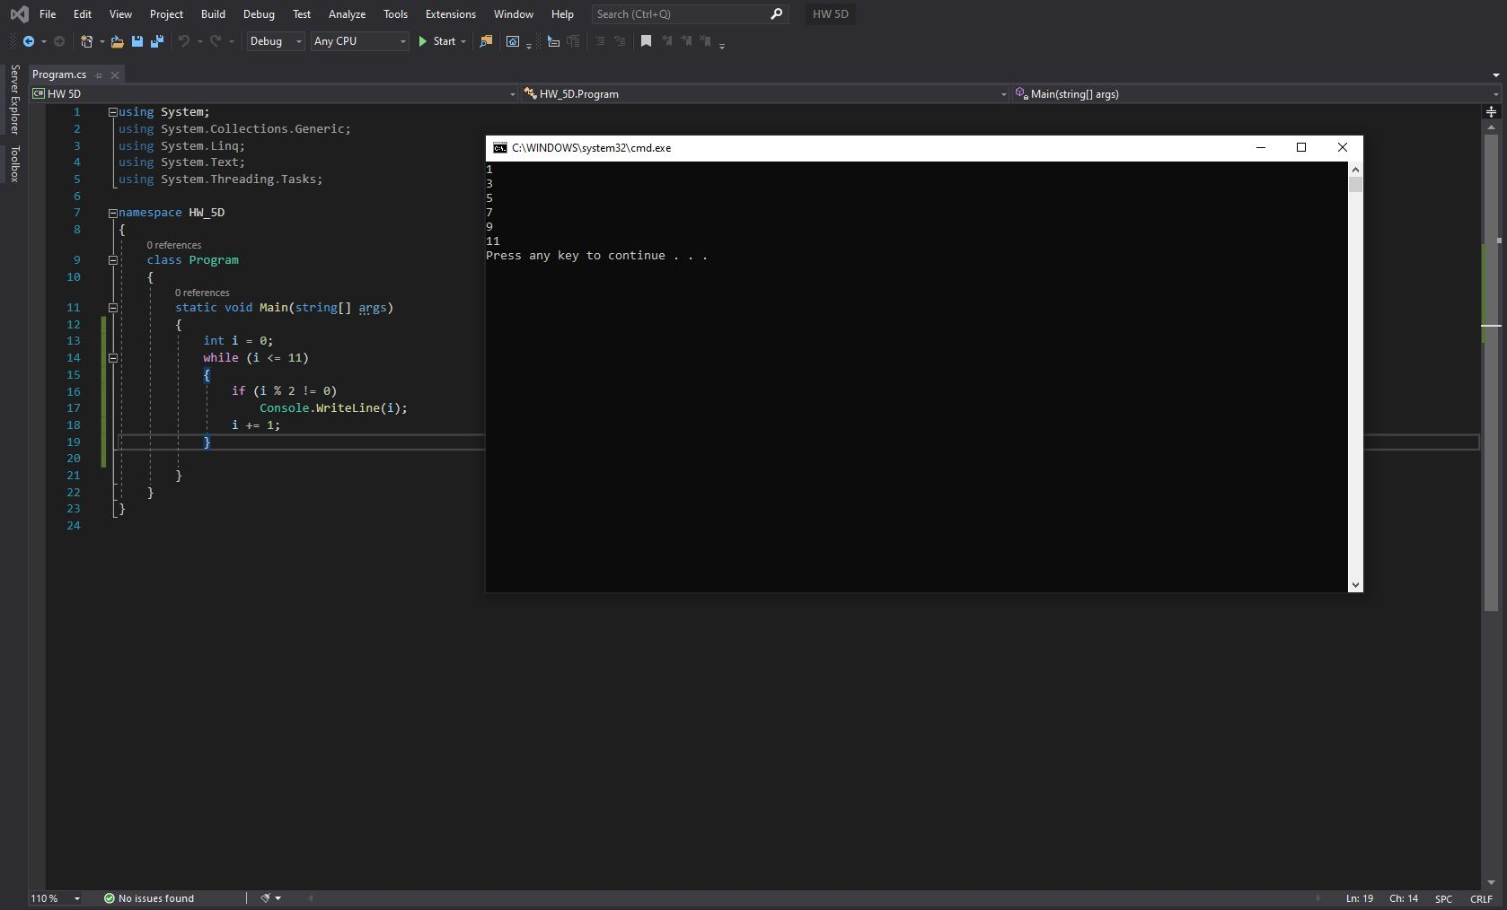

1. **Write a do loop that prints out the odd numbers from 1 to 11. Use the compound assignment operator += to increment your counter variable.**

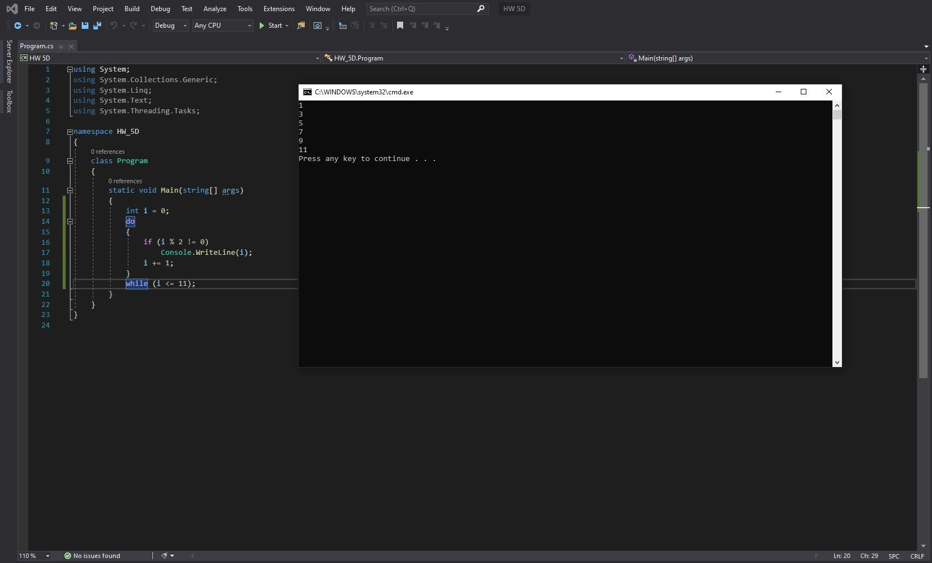

1. **Write a snippet of code which:** 
   * **calls int.parse("17")**
   * **handles the appropriate exception if thrown**
   * **outputs “Done!” to the screen regardless of whether an exception is thrown**

